Aim : Generate Histogram of Images, apply Histogram Equalization

GitHub : https://github.com/mankumarbhalodiya/Digital-Signal-and-Image-Processing/tree/main/Experiment%208

Introduction :

1. Histogram Equalization
Histogram equalization is used to improve the contrast of an image by redistributing its intensity values over a wider range. It works mainly by using the histogram and cumulative distribution of the image.
For degraded images with low contrast, many pixels are usually concentrated in a small intensity range. Histogram equalization spreads these intensity values, making dark regions darker and bright regions brighter. The histogram provides useful information about the brightness and contrast of an image. Histogram equalization uses the Cumulative Distribution Function (CDF) of the image histogram.
First, the histogram of the input image is calculated. Then, the probability of occurrence of each intensity level is calculated.
In many real-world images, the intensity values are not distributed across the complete grayscale range. For example, an image captured in poor lighting may contain most of its pixels in the lower intensity range. Similarly, an overexposed image may have most pixels concentrated in the higher intensity range.

2. Histogram Matching
Histogram matching, also called histogram specification, changes the intensity distribution of an input image so that its histogram becomes similar to that of a selected reference image.
Unlike histogram equalization, which automatically tries to produce a more evenly distributed histogram, histogram matching gives more control over the final appearance because a reference image determines the desired intensity distribution.
For example, suppose a degraded image is dark and has poor contrast. If a good-quality image with the desired brightness and contrast is selected as the reference, histogram matching can transform the degraded image so that its intensity distribution becomes similar to the reference image.
Sometimes simply increasing the contrast of an image is not enough. We may want the enhanced image to have a particular brightness and contrast distribution.

3. Effect of Histogram Equalization

Improved Contrast : The most important effect is improvement in contrast. If the original image contains intensity values within a small range, equalization expands them across a wider range.

Better Visibility of Details : Details that were difficult to see because they were present in dark or bright regions may become more visible.

Improved Brightness Distribution : The intensity distribution becomes more spread out, allowing the image to use more of the available grayscale range.

Possible Noise Enhancement : One disadvantage is that histogram equalization can also enhance unwanted noise. If noise exists in a particular intensity region, the redistribution process may make that noise more visible.

Possible Unnatural Appearance : For some images, especially images that already have good contrast, histogram equalization may produce excessive contrast and make the image look unnatural.

Code :
import os
import cv2
import numpy as np
import matplotlib.pyplot as plt
from skimage.exposure import match_histograms

script_dir = os.path.dirname(os.path.abspath(__file__))
output_dir = os.path.join(script_dir, "Outputs")
os.makedirs(output_dir, exist_ok=True)

degraded_files = [
"1.jpg",
"2.jpg",
"3.jpg",
"4.jpg",
"5.jpg"
]

reference_files = [
"1_ref.jpg",
"2_ref.jpg",
"3_ref.jpg",
"4_ref.jpg",
"5_ref.jpg"
]

for degraded_file, reference_file in zip(degraded_files, reference_files):

degraded_path = os.path.join(script_dir, degraded_file)
reference_path = os.path.join(script_dir, reference_file)

image = cv2.imread(degraded_path, cv2.IMREAD_GRAYSCALE)
reference = cv2.imread(reference_path, cv2.IMREAD_GRAYSCALE)

if image is None:
print("Degraded image not found:", degraded_file)
continue

if reference is None:
print("Reference image not found:", reference_file)
continue
equalized = cv2.equalizeHist(image)
matched = match_histograms(image, reference)
matched = np.clip(matched, 0, 255).astype(np.uint8)
fig, axes = plt.subplots(2, 4, figsize=(16, 8))
axes[0, 0].imshow(image, cmap="gray")
axes[0, 0].set_title("1. Degraded Image", fontsize=10, fontweight="bold")
axes[0, 0].axis("off")
axes[0, 1].imshow(reference, cmap="gray")
axes[0, 1].set_title("2. Reference Image", fontsize=10, fontweight="bold")
axes[0, 1].axis("off")
axes[0, 2].imshow(equalized, cmap="gray")
axes[0, 2].set_title("3. Histogram Equalized", fontsize=10, fontweight="bold")
axes[0, 2].axis("off")
axes[0, 3].imshow(matched, cmap="gray")
axes[0, 3].set_title("4. Histogram Matched", fontsize=10, fontweight="bold")
axes[0, 3].axis("off")
axes[1, 0].hist(image.ravel(), bins=256, range=[0, 256], color="gray")
axes[1, 0].set_title("Degraded Histogram")
axes[1, 0].set_xlabel("Intensity")
axes[1, 0].set_ylabel("Frequency")
axes[1, 1].hist(reference.ravel(), bins=256, range=[0, 256], color="green")
axes[1, 1].set_title("Reference Histogram")
axes[1, 1].set_xlabel("Intensity")
axes[1, 2].hist(equalized.ravel(), bins=256, range=[0, 256], color="blue")
axes[1, 2].set_title("Equalized Histogram")
axes[1, 2].set_xlabel("Intensity")
axes[1, 3].hist(matched.ravel(), bins=256, range=[0, 256], color="purple")
axes[1, 3].set_title("Matched Histogram")
axes[1, 3].set_xlabel("Intensity")
plt.suptitle(
f"Image Enhancement Comparison: {degraded_file} vs {reference_file}",
fontsize=13,
fontweight="bold"
)
plt.tight_layout()

base_name = os.path.splitext(degraded_file)[0]
fig_path = os.path.join(output_dir, f"result_{base_name}.png")
plt.savefig(fig_path, dpi=200)
plt.close()
print(
degraded_file,
"processed successfully. Output saved to Outputs/result_"
+ base_name
+ ".png"
)
print("All images processed successfully.")

Output :
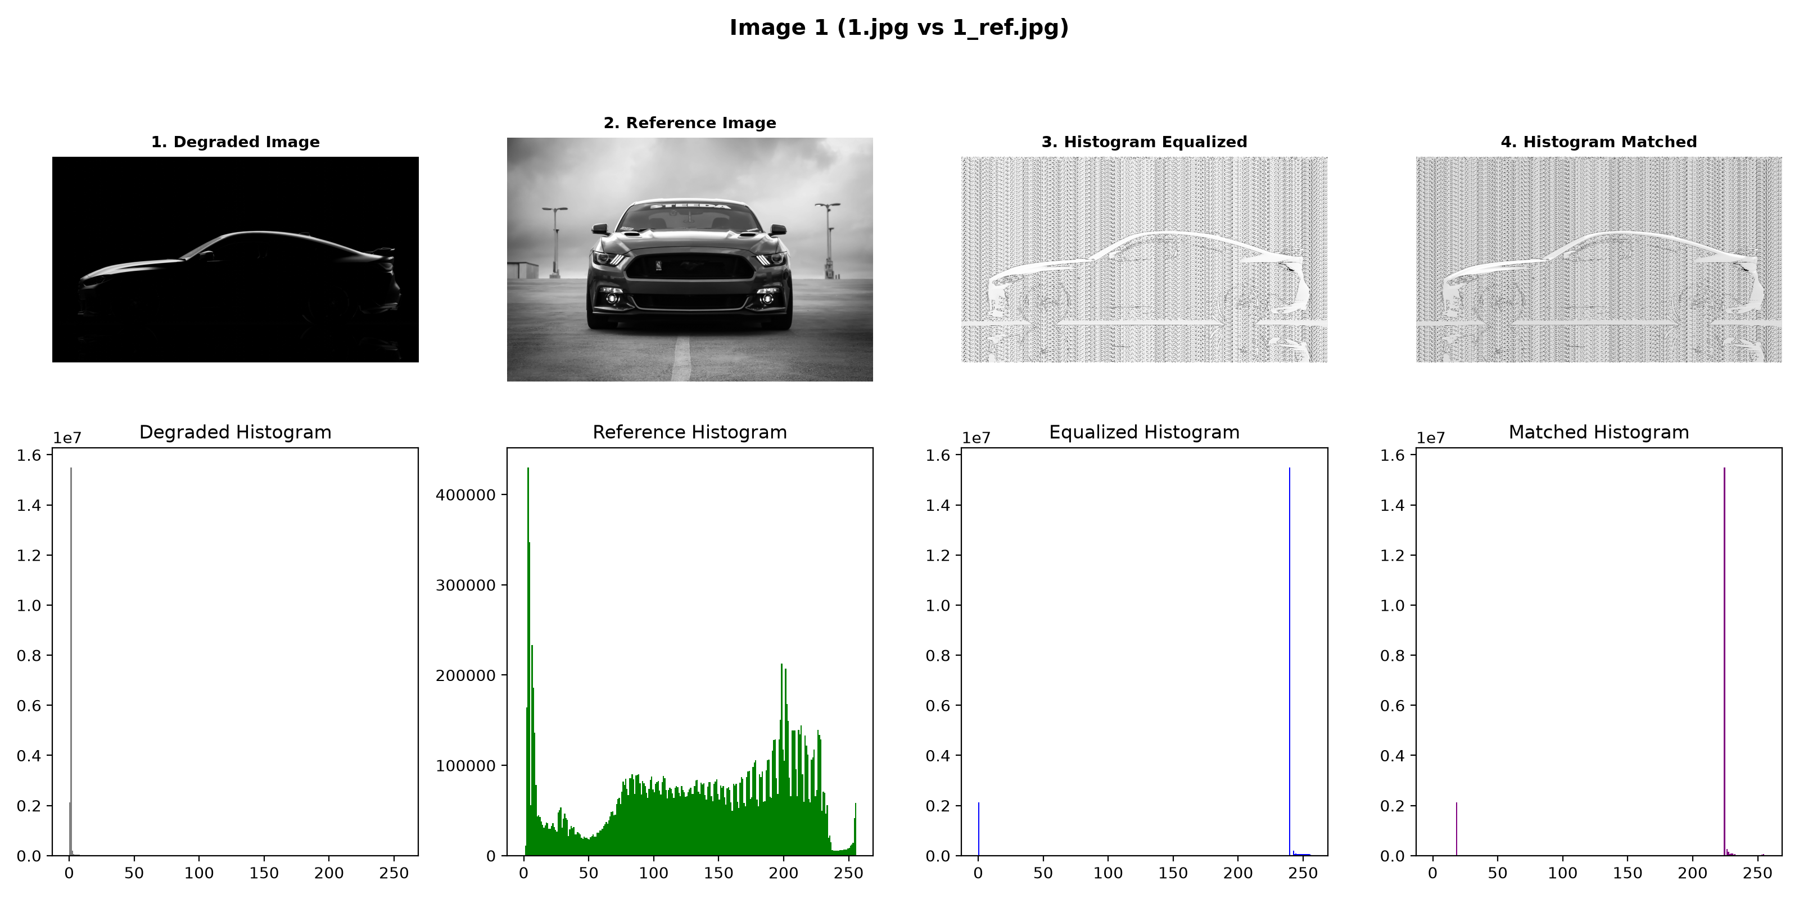
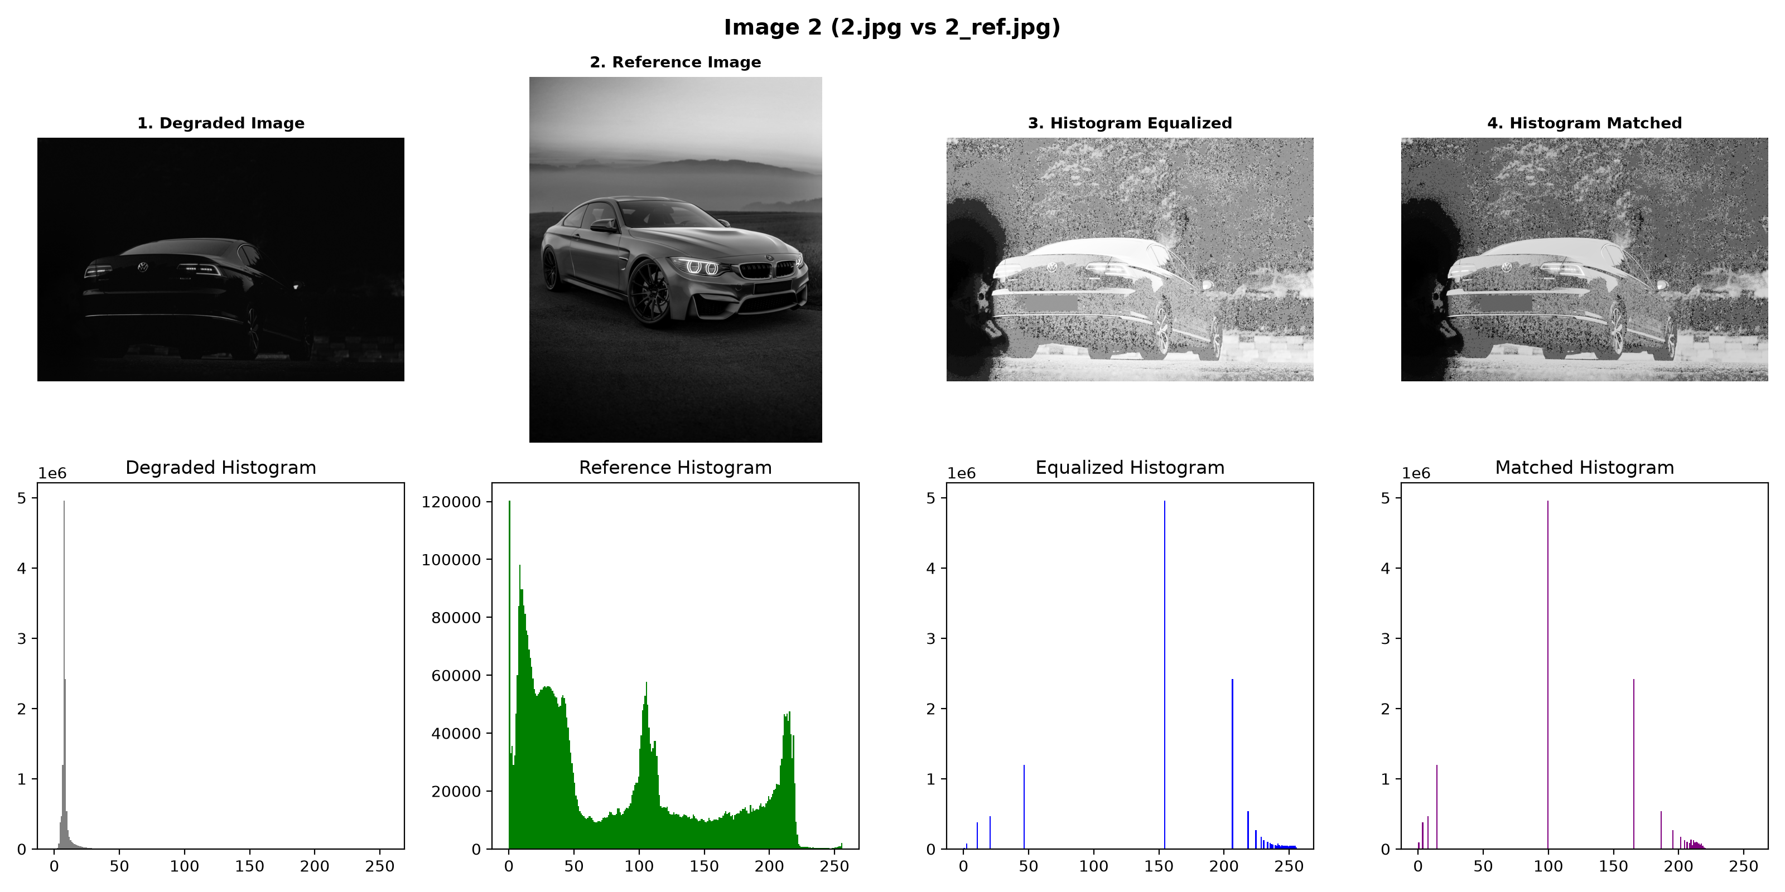

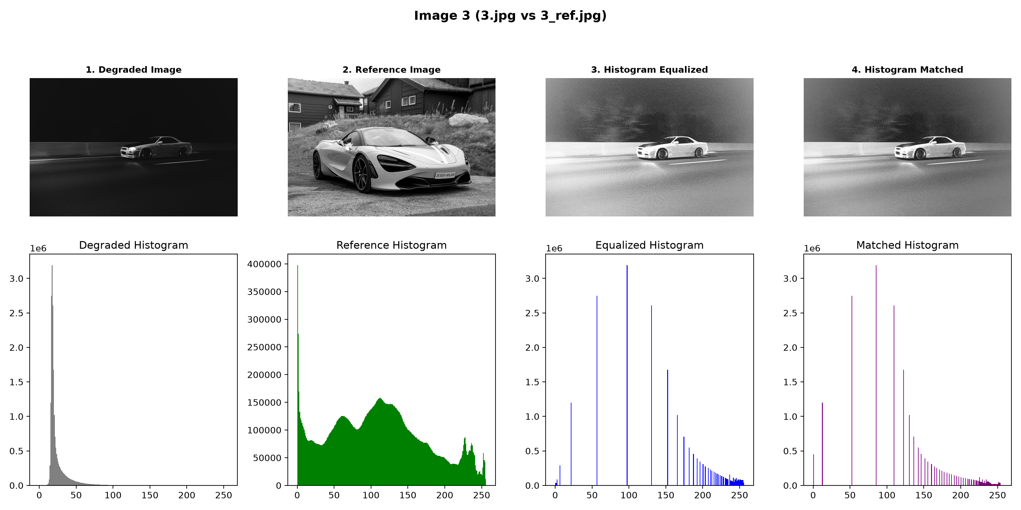
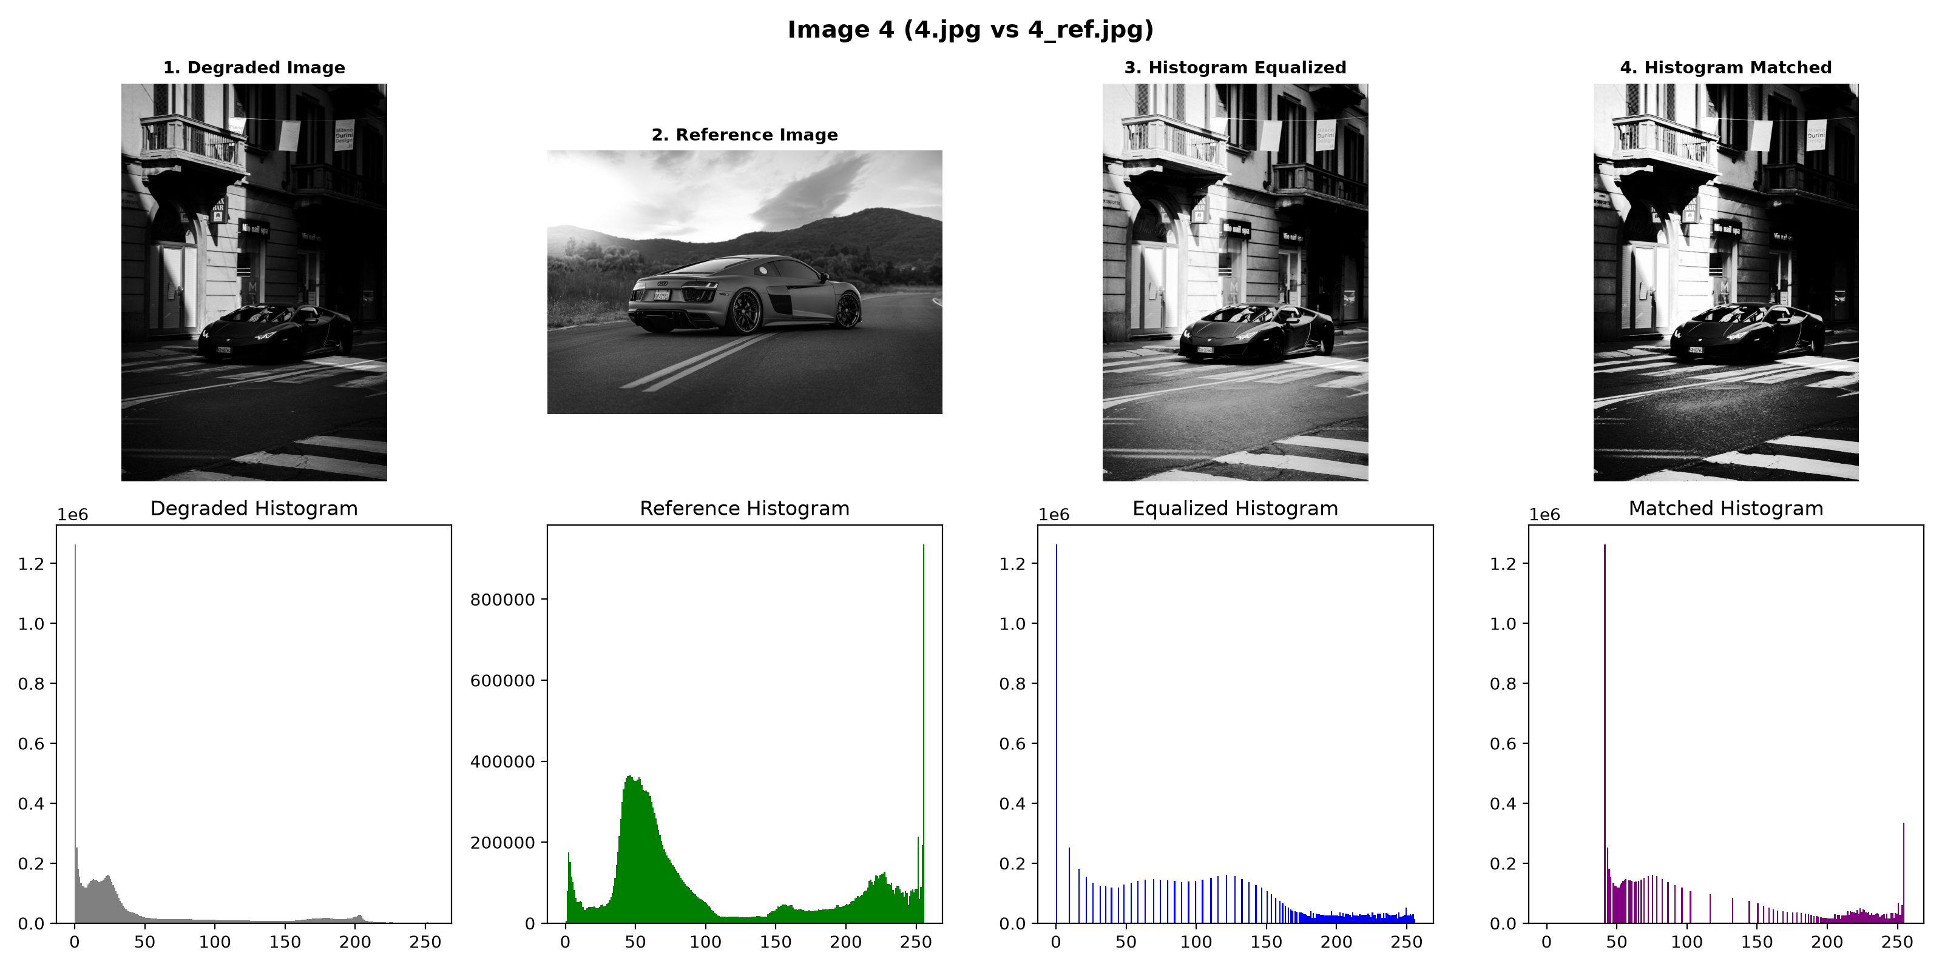

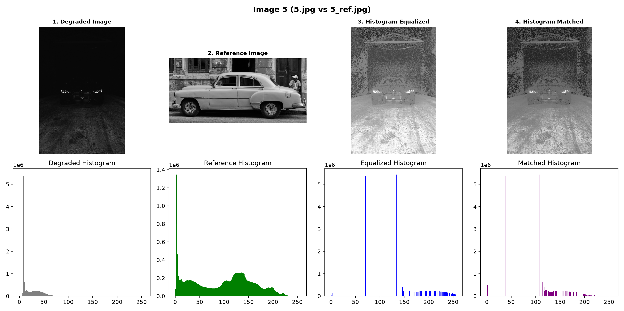

Conclusion :
This experiment helped us understand how histogram-based techniques can improve the quality of degraded images. Histogram Equalization improved the contrast by spreading the intensity values over a wider range, which made many details more visible. However, for very dark images, it sometimes produced an over-enhanced result because most of the original pixels were concentrated near black.
Histogram Matching gave more controlled results because it used a reference image to adjust the brightness and contrast of the degraded image. The output depended mainly on how suitable the reference image was. Overall, Histogram Equalization worked better for images with low contrast, while Histogram Matching was more useful when a good reference image was available. The experiment showed that the choice of technique depends on the condition of the image and the type of enhancement required.

